The Battle of Culloden - Letter
Imagine that you are a Jacobite at Culloden in 1746. On the morning of the battle write a letter home to your family.

In your letter you should -
- Reassure your parents that you are ok.
- Tell them a bit about your exciting journey into England with Bonnie Prince Charlie.
- Describe how you are feeling on the morning of the battle (after your night march)
- Tell them about your hopes and fears for the upcoming battle
- Say goodbye

Here are some sentence starters if you get stuck -
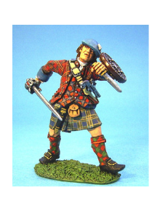
- I’m with the Jacobite army at a place called Culloden Moor and we are getting ready to fight the British Redcoats. I feel …
- Since I last saw you all those months ago I have seen some amazing things such as …
- I think the ____________ army are going to win here at Culloden because…
- I am very tired and hungry because last night Lord George Murray made us ______________________ . This was because…
- I hope that I get home soon,…
- I miss you all. I really miss …

