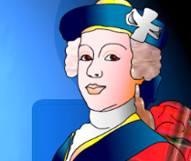
After the Battle of Culloden, Charles fled the mainland and made for the Hebrides, outwitting both a massive military cordon and a reward of £30,000 which had been offered to anyone prepared to betray him.
Task
Complete a Wanted poster for Bonnie Prince Charlie

These posters are for display so take your time and impress me! Look at posters at the front of the room for inspiration.
If you finish your poster you can complete extension work in the back of the Jacobite booklet.

After the Battle of Culloden, Charles fled the mainland and made for the Hebrides, outwitting both a massive military cordon and a reward of £30,000 which had been offered to anyone prepared to betray him.
Task
Complete a Wanted poster for Bonnie Prince Charlie

These posters are for display so take your time and impress me! Look at posters at the front of the room for inspiration.
If you finish your poster you can complete extension work in the back of the Jacobite booklet.

